MAJOR PROJECT REPORT
On
“GLOBEXA – AI POWERED TRAVEL PLANNING SYSTEM”

Submitted for the partial fulfilment of the requirement for Major project work of 6th semester of Bachelor of Computer Application (BCA) programme.

Department of Computer Science
NERIM GROUP OF INSTITUTIONS
Padma Nath Sharma Bhawan, Jayanagar, Guwahati-22

Submitted by
Name: Arindom Borgohain
Roll No: 23992163
Registration No: C2300621

Internal Guide External Guide
Rinti Borah Alakesh Gogoi
Assistant professor Tech Operations Manager
Nerim Group of Institutions Prismabit Digital Solution

CERTIFICATE OF APPROVAL

This is to certify that the project work entitled “GLOBEXA – AI POWERED TRAVEL PLANNING SYSTEM” is carried out by Arindom Borgohain bearing exam roll no 23992163, registration no C2300621 of NERIM under the organizational guidance of Alakesh Gogoi, Tech Operations Manager, Prismabit Digital Solutions LLP and internal guidance of Internal Guide Name has been found satisfactory and is hereby approved as a major project work carried out and presented in a manner required for its acceptance in partial fulfillment of the course work of 6th semester of 3 year full time BCA course under NERIM,Guwahati

Internal Examiner: External Examiner:
Date : Date :
Place: NERIM, Guwahati

CERTIFICATE FROM HOD

This is to certify that the project work entitled “GLOBEXA – AI POWERED TRAVEL PLANNING SYSTEM”is carried out by Arindom Borgohain bearing exam roll no 23992163, registration no C2300621 under the organizational guidance of Alakesh Gogoi and internal guidance of Internal Guide Name in partial fulfillment of major project work of BCA 6th semester under NERIM,Guwahati

Date: Dr Tarali kalita
HoD, Computer Science
NERIM, Guwahati

CERTIFICATE FROM ORGANIZATIONAL GUIDE
This is to certify that Arindom Borgohain has successfully completed the project titled
“GLOBEXA – AI POWERED TRAVEL PLANNING SYSTEM”
during the period from 16 January 2026 to 30 April 2026 at Prismabit Digital Solutions LLP under my supervision.
Alakesh Gogoi
Tech Operations Manager
Prismabit Digital Solutions LLP

CERTIFICATE FROM INTERNAL GUIDE

This is to certify that the project work entitled “ Globexa“ is a bona-fide work carried out by Arindom Borgohain bearing exam roll no 23992163, registration no C2300621 of BCA 6th Semester of 3 year full time BCA course under Dibrugarh University at NERIM under my supervision and guidance. The report is found worthy of acceptance for the partial fulfillment of major project work of BCA 6th semester under 3 year full time BCA program under Dibrugarh University, Dibrugarh, Assam.

All helps received have been duly acknowledged, and no part of this report has been reproduced for any other degree or diploma.

Date: Rinti Borah
Assistant Professor
Computer Science Department
NERIM

PROFORMA
1. Name of the Student
Arindom Borgohain
2. Roll no +
23992163
3. Registration Number
C2300621
4. Course: Bachelor of Computer Application (BCA)
5. Semester: 6th Semester
6. Department: Department of Computer Science
7. Name of the Organization
Prismabit Digital Solutions LLP
8. Project Title: GLOBEXA – AI POWERED TRAVEL PLANNING SYSTEM
9. Name of Internal Guide: Rinti Borah
10. Name of Organizational Guide: Alakesh Gogoi
11. Duration of the Project: January 2026 – April 2026
12. Name & Address of the Guide: Alakesh Gogoi
Prismabit Digital Solutions LLP
Vip road, Udayan Path
13. Qualification of the Guide: Master's in computer application
14. Working Experience of the Guide: 2+ Years

Student Date External Guide Date Internal Guide Date

ACKNOWLEDGEMENT

At the very inception, I would like to express my sincere gratitude to Alakesh Gogoi, Tech Operations Manager, Prismabit Digital Solutions LLP, for his guidance and support throughout the project.I would also like to thank the Head of Department, Computer Science, NERIM for valuable suggestions. I express my heartfelt thanks to my internal guide for continuous guidance and encouragement.

With regards

Arindom Borgohain

Registration No: C2300621

Roll No: 23992163

BCA 6th semester

DECLARATION

I hereby declare that the project work called " Globexa" submitted to the Computer Science Department of NERIM, Guwahati under Dibrugarh University is a record of an original work done by me under the guidance of “Alakesh Gogoi from Prismabit Digital Solution ” and “ Rinti Borah Assistance professor of Nerim” and this project is submitted for the partial fulfilment of the degree of Bachelor of Computer Application under Dibrugarh University, Dibrugarh, Assam. The results embodied in this, have not been submitted to any other University or Institute.

With regards

Arindom Borgohain

Registration No: C2300621

Roll No: 23992163

BCA 6th semester

CONTENTS
Chapter 1: Introduction
1.1 BRIEF BACKGROUND OF THE ORGANIZATION
1.2 Title of the projec
1.3 Introduction
1.4 Project Definition
1.5 Existing System
1.6 Proposed System
1.7 Objectives of the proposed System
1.8 Hardware and Software Used in the Project
Chapter 2: Literature Review
2.1 Aim
2.2 Methodologies Used
2.3 Results
Chapter 3: Research Gap & Research Motivation
3.1 Research Gap
3.2 Research Motivation

Chapter 4: RESEARCH OBJECTIVES
Chapter 5: Feasibility Study
5.1 Technical Feasibility
5.2 Economic Feasibility
5.3 Operational Feasibility
5.4 Behavioral Feasibility

Chapter 6: TECHNOLOGY, DATASETS AND MODELS IMPLEMENTED

6.1 Technology Used
6.2 Dataset
6.3 Model Used

Chapter 7: System Design
7.1 System Flow
7.2 Architecture

Chapter 8: GRAPHICAL REPRESENTATION
Chapter 9: RESULTS AND DISCUSSION
9.1 Observations
9.2 Interpretation
9.3 Novelty of Project

Chapter 10: Screenshots

10.1 Homepage
10.2 Login page
10.3 Ai Travel planner
10.4 Booking
Chapter 11: Conclusion And Future Scope
11.1 Conclusion
11.2 Future Scope
Chapter 13: References

Chapter 1: Introduction

1.1 BRIEF BACKGROUND OF THE ORGANIZATION

Prismabit Digital Solutions LLP is a software development and digital transformation company that provides innovative technology solutions for businesses and organizations across multiple industries. The company specializes in web application development, mobile application development, cloud-based systems, Artificial Intelligence integration, database management systems, CRM software, and customized enterprise solutions. The organization focuses on building scalable, secure, and user-friendly applications using modern technologies and development practices. Prismabit Digital Solutions LLP has worked on several projects related to agriculture, education, healthcare, customer relationship management, e-commerce, and business automation systems. The company continuously explores modern technologies such as Artificial Intelligence (AI), Machine Learning (ML), API-based systems, cloud computing, and automation to improve digital services and provide smarter solutions for real-world problems. Through innovation and practical implementation, the company aims to simplify business processes and improve user experience using technology-driven approaches.

1.2 TITLE OF THE PROJECT
“GLOBEXA – AI POWERED TRAVEL PLANNING SYSTEM USING DBMS AND OPENROUTER API”

1.3 INTRODUCTION
In today’s digital era, travel planning has become increasingly complex due to the availability of multiple platforms and scattered information. Users often need to visit different websites for booking hotels, transportation, and planning itineraries, which leads to inefficiency and confusion. The proposed system, Globexa, is designed to solve this problem by integrating Database Management Systems (DBMS) with Artificial Intelligence (AI). The system provides a centralized platform where users can browse destinations, book services, and generate personalized travel itineraries. The AI functionality is implemented using the OpenRouter API, which utilizes pre-trained large language models (LLMs) to generate travel plans dynamically based on user preferences such as budget, location, and duration. This project demonstrates how modern AI technologies can be integrated with traditional web applications to enhance user experience without requiring complex machine learning model training.

1.4 PROJECT DEFINITION

Globexa is an AI-powered travel planning system designed to simplify and automate the process of travel management and itinerary planning. In today’s digital era, users often face difficulties while planning trips because travel-related information is scattered across multiple platforms. People generally need to use different applications or websites for hotel booking, transportation booking, travel scheduling, and destination planning, which increases complexity and consumes time. The proposed system aims to solve these problems by providing a centralized platform where users can manage all travel-related activities efficiently. The application allows users to create accounts, browse destinations, book travel services, and generate intelligent travel itineraries using Artificial Intelligence. The AI functionality is implemented through OpenRouter API integration, which uses pre-trained Large Language Models (LLMs) to generate personalized travel plans according to user preferences such as:
- Budget
- Travel duration
- Preferred destination
- Interests and activities
- Number of travelers The system uses Database Management System (DBMS) for efficient storage and management of user data, booking information, destinations, and AI-generated itineraries. The project demonstrates how modern Artificial Intelligence technologies can be integrated into traditional web applications to improve automation, personalization, and user experience without requiring complex AI model training. The primary goal of the system is to provide a smart, efficient, and user-friendly travel planning platform suitable for real-world applications.

1.5 EXISTING SYSTEM

Existing travel planning systems such as MakeMyTrip, TripAdvisor, Expedia, Booking.com, and Google Travel provide online platforms where users can search destinations, book hotels, reserve transportation, and explore travel packages. These platforms have simplified online travel booking and made travel services more accessible to users. Although these systems provide a wide range of travel-related services, several limitations still exist:
- Users often need to switch between multiple platforms for complete trip planning.
- Most systems provide static recommendations instead of personalized intelligent itineraries.
- Travel plans are usually manually prepared by users, which consumes time and effort.
- Some systems lack intelligent AI-based travel recommendation features.
- Existing platforms mainly focus on bookings rather than complete automated travel planning.
- Many systems do not dynamically generate itineraries according to user preferences and budget. Examples of Existing Systems: MakeMyTrip MakeMyTrip is one of the leading travel booking platforms in India that provides hotel booking, flight booking, holiday packages, and transportation services. TripAdvisor TripAdvisor provides travel reviews, destination information, and hotel recommendations based on customer reviews and ratings. Expedia Expedia is an international travel booking platform that allows users to book hotels, flights, rental cars, and vacation packages. Google Travel Google Travel helps users explore destinations, find hotels, and organize travel plans using Google services. Despite their advantages, these systems still have limitations in AI-based intelligent travel automation and dynamic itinerary generation, which creates the need for a smarter and more personalized system like Globexa.

1.6 PROPOSED SYSTEM

The proposed system “GLOBEXA – AI Powered Travel Planning System” is designed to provide a centralized, intelligent, and automated travel planning platform using Database Management System (DBMS) and Artificial Intelligence. The system allows users to:
- Register and manage secure accounts.
- Browse travel destinations and services.
- Book hotels and travel-related services.
- Generate personalized AI-based itineraries.
- Store travel history and booking information.
- Receive smart travel recommendations based on user preferences. The most important feature of the system is AI-powered itinerary generation using OpenRouter API. The AI system dynamically generates travel plans based on user inputs such as:
- Budget
- Destination
- Travel duration
- Interests
- Preferred activities Unlike traditional travel systems, Globexa provides intelligent recommendations instead of static information. The AI analyzes user preferences and generates personalized travel schedules that improve convenience and reduce manual planning effort. Key Features of the Proposed System:
- AI-based personalized itinerary generation.
- Centralized travel planning platform.
- User-friendly interface.
- Real-time intelligent recommendations.
- Secure database management using MySQL.
- API-based AI integration without custom model training.
- Fast response generation and efficient data management. The proposed system aims to improve user experience, automate travel planning, and demonstrate practical implementation of Artificial Intelligence in modern web applications.

1.7 OBJECTIVES OF THE PROPOSED SYSTEM

The objectives of the proposed system are as follows:
- To design and develop a smart travel planning system using DBMS and Artificial Intelligence.
- To provide a centralized platform for travel planning and booking management.
- To integrate OpenRouter API for AI-based itinerary generation.
- To generate personalized travel recommendations based on user preferences.
- To reduce the complexity and time required for manual travel planning.
- To provide a secure and user-friendly web application.
- To demonstrate practical implementation of Artificial Intelligence in real-world systems.
- To improve user experience through automation and intelligent recommendations.
- To efficiently store and manage user and booking data using MySQL database.

1.8 HARDWARE AND SOFTWARE USED IN THE PROJECT

HARDWARE SPECIFICATIONS
PROCESSOR
Intel Core i5 or higher processor is recommended for smooth application performance and efficient handling of backend processes.
RAM
Minimum 4GB RAM is required for proper execution of the application and server environment.
HARD DISK
At least 50GB storage capacity is required for software installation, database storage, and project files.
KEYBOARD
Standard keyboard for user interaction and development purposes.
MOUSE
Optical mouse for navigation and development activities.
SOFTWARE SPECIFICATIONS OPERATING SYSTEM
Windows 10 or higher operating system is used for development and deployment of the project.
SERVER
XAMPP server is used to run Apache server and MySQL database locally during development and testing. FRONT-END TECHNOLOGIES The front-end of the application is developed using:
- HTML5
- CSS3
- JavaScript
- Bootstrap These technologies are used to create responsive and user-friendly web pages. BACK-END TECHNOLOGY PHP is used as the backend programming language for handling business logic, database operations, API integration, and server-side processing. DATABASE MySQL database is used for storing:
- User information
- Booking records
- Destination details
- Payment information
- AI-generated itineraries AI INTEGRATION OpenRouter API is used to integrate Artificial Intelligence functionality into the application. It allows the system to communicate with pre-trained Large Language Models (LLMs) for generating intelligent travel itineraries and recommendations. WEB BROWSER Google Chrome and Microsoft Edge are used for application testing and execution.

Chapter 2: LITERATURE REVIEW

2.1 Aim

The main aim of this study is to examine existing travel planning systems and AI-based recommendation technologies in order to understand their working principles, advantages, and limitations. The study focuses on identifying effective methods for travel personalization, automation, and intelligent recommendation generation.The research also aims to analyze how Artificial Intelligence and Database Management Systems can work together to create a more efficient and user-friendly travel planning platform.

2.2 Methodologies Used

Different methodologies and technologies are used in modern travel planning systems. Rule-based systems generate recommendations using predefined conditions and fixed logic. Although simple, these systems cannot provide dynamic suggestions according to changing user needs. Machine learning models analyze user behavior, booking history, and preferences to generate personalized recommendations. Collaborative filtering techniques are commonly used in travel and e-commerce platforms to recommend destinations or hotels based on similar user interests. Recently, Generative AI models and Large Language Models (LLMs) have become popular because they can generate human-like responses and dynamic travel itineraries. API-based AI integration methods, such as OpenRouter API, simplify AI implementation by allowing developers to use pre-trained AI models without building their own machine learning systems.

Various methodologies have been used in existing systems:
- Rule-based systems that provide static recommendations
- Machine learning models that analyze user behavior
- Collaborative filtering techniques for recommendation
- Generative AI models (LLMs) for dynamic content generation
- API-based AI integration for real-time responses

2.3 Results
- AI-based systems significantly improve personalization
- API-based approaches reduce development complexity
- DBMS ensures efficient storage and retrieval of user data
- Generative AI provides flexible and human-like responses

Chapter 3: RESEARCH GAP & MOTIVATION

3.1 Research Gap

Many existing travel planning systems still have limitations. Some systems require large datasets and complex AI model training, which increases development cost and difficulty.
Many applications also lack proper integration between booking systems and AI recommendation systems. Some platforms provide only static suggestions instead of personalized recommendations.

Despite advancements, several limitations exist:
- Most systems require large datasets and training models
- Complex implementation of AI algorithms
- Lack of integration between booking systems and AI
- High computational cost of machine learning models

3.2 Research Motivation
The motivation behind this project is to:
- Develop a simple yet powerful system using API-based AI
- Avoid the complexity of training models
- Combine DBMS efficiency with AI intelligence
- Create a real-world usable application

Chapter 4: RESEARCH OBJECTIVES
- To design and develop a DBMS-based travel management system
- To integrate AI-based itinerary generation using OpenRouter API
- To provide user-friendly interface for booking and planning
- To enhance travel planning through automation
- To demonstrate practical implementation of AI in web systems

Chapter 5 FEASIBILITY STUDY

5.1 Technical Feasibility

The proposed system is technically feasible because it uses commonly available web development technologies such as HTML, CSS, JavaScript, PHP, and MySQL. These technologies are widely used and supported, making system development easier and more reliable. The AI functionality is integrated using OpenRouter API, which eliminates the need for complex machine learning infrastructure or model training. The system can run on standard web hosting platforms without requiring advanced hardware resources.
The project architecture is simple, scalable, and suitable for academic as well as real-world applications.

5.2 Economic Feasibility

The project is economically feasible because it mainly uses open-source technologies and requires minimal investment. No expensive GPU systems or paid machine learning tools are needed for development.
Using API-based AI integration significantly reduces development and maintenance costs because the system uses pre-trained AI models instead of building custom AI systems.
The project is cost-effective and suitable for small-scale businesses, educational purposes, and startup-level implementations.

5.3 Operational Feasibility
The system is easy to operate and can run on standard web browsers. Users can interact with the system without any technical knowledge.

5.4 Behavioral Feasibility
The user interface is simple and intuitive, ensuring user acceptance and ease of use.

Chapter 6: TECHNOLOGY, DATASETS AND MODELS IMPLEMENTED

6.1 Technology Used
- Frontend: HTML, CSS, JavaScript
- Backend: PHP
- Database: MySQL
- AI Integration: OpenRouter API

6.2 Dataset
This project does not use a traditional dataset for training. Instead, it uses:
- Stored database records (users, bookings, destinations)
- User input data for AI processing

6.3 Model Used

The system uses a pre-trained Large Language Model (LLM) via OpenRouter API.
Type: Pre-trained model (API-based)
No custom training required

Chapter 7: SYSTEM DESIGN & ARCHITECTURE

7.1 System Flow
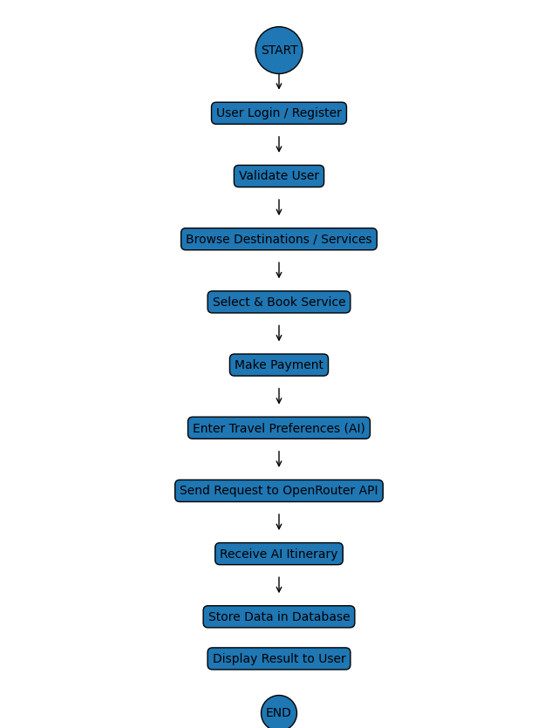

7.2 Architecture
The system follows a hybrid architecture:
- DBMS for data management
- API-based AI for intelligent processing
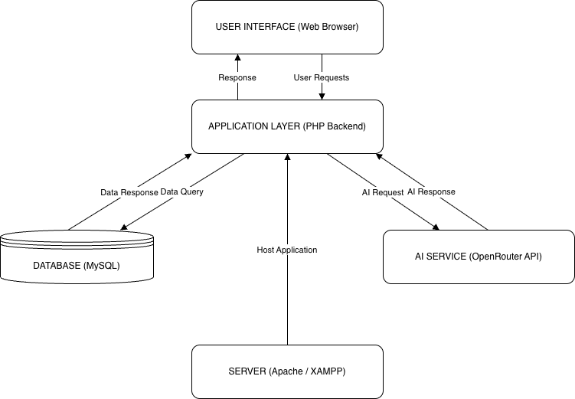

Chapter 8: GRAPHICAL REPRESENTATION
Since the system uses a pre-trained AI model through API, no training or validation process is involved.
Therefore:
- No loss/accuracy graphs
- No epochs or training curves
Performance is evaluated based on:
- Accuracy of generated responses
- Relevance of recommendations

Chapter 9: RESULTS AND DISCUSSION
The system was successfully implemented and tested. The AI module generates meaningful travel itineraries based on user input.

9.1 Observations

The Globexa system was successfully developed and tested. The AI module generated personalized travel itineraries according to user preferences such as budget, location, and travel duration.The system showed fast response generation and provided meaningful travel suggestions. The database efficiently handled user information, bookings, and destination details without major issues.The user interface was simple and interactive, making the application easy to use

This is the main point:
- Fast response generation
- Relevant and personalized suggestions
- Efficient database handling

9.2 Interpretation

The results indicate that the integration of Artificial Intelligence with Database Management Systems improves travel planning efficiency and user experience.The AI module helps users by automatically generating personalized itineraries, while the database system manages and stores information in an organized manner.Using API-based AI integration reduces the complexity of implementing machine learning systems while still providing intelligent and dynamic results.The project also proves that AI can be practically integrated into web applications for solving real-world problems effectively.

In Simple point :
- AI improves user experience significantly
- DBMS ensures structured data management
- API-based AI reduces system complexity

9.3 Novelty of Project

The main novelty of the project is the combination of Artificial Intelligence and DBMS in a practical travel planning application. Unlike traditional systems that require custom machine learning model training, this project uses API-based AI integration through OpenRouter API. This approach reduces development complexity and hardware requirements. The system provides real-time intelligent itinerary generation, personalized recommendations, and centralized booking management within a single platform.
The project demonstrates a modern and cost-effective approach to integrating AI into web applications.

In Simple Point :
- Combines DBMS + AI in a practical system
- Uses API-based AI instead of training models
- Provides real-time intelligent responses

Chapter 10: Screenshot

10.1: Homepage

10.2: Login page

10.3 Ai Travel Planner

10.3 Booking

Chapter 11: CONCLUSION AND FUTURE SCOPE

11.1 Conclusion
The Globexa system successfully demonstrates how AI can be integrated with DBMS to create a smart travel planning platform. By using OpenRouter API, the system avoids the complexity of model training while still delivering intelligent and dynamic results.
This approach makes the system scalable, efficient, and suitable for real-world applications.

11.2: FUTURE SCOPE
- Integration with real-time booking APIs
- Development of mobile application
- Voice-based AI assistant
- Machine learning-based personalization
- Real-time price optimization
- Multi-Language support
- Gps and Map Integration

Chapter 13: REFERENCES
- Smith, J. (2022). AI in Travel Systems. Journal of AI Research.
- Brown, R. (2021). Database Management Systems. Springer.
- OpenRouter API Documentation
- W3Schools Web Development
- OpenAI and large language Model
- Mozilla Developer Network (MDN)
- Pressman, R. (2014) .Software Engineering

